EX NO 14: Counting Vowels and Consonants Using LEX

Aim:
To write a LEX program to read a sentence from an input file and count the vowels and consonants separately, ignoring spaces, digits, and special characters.
Algorithm:
- Start the program.
- Initialize vowel and consonant counters to zero.
- Read the input file character by character.
- Increment the vowel counter for A, E, I, O, U and their lowercase letters.
- Increment the consonant counter for other alphabetic characters.
- Display the total number of vowels and consonants.
- Stop the program.

Program:

%{
#include <stdio.h>
int vowels = 0, consonants = 0;
%}

%%
[AaEeIiOoUu] { vowels++; }
[A-Za-z] { consonants++; }
.|\n ;
%%

int main()
{
yylex();
printf("Total vowels = %d\n", vowels);
printf("Total consonants = %d\n", consonants);
return 0;
}

int yywrap()
{
return 1;
}
Sample input:

Sample output:
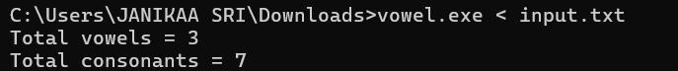

Result:
The LEX program was executed successfully and counted the vowels and consonants separately in the given input sentence.

